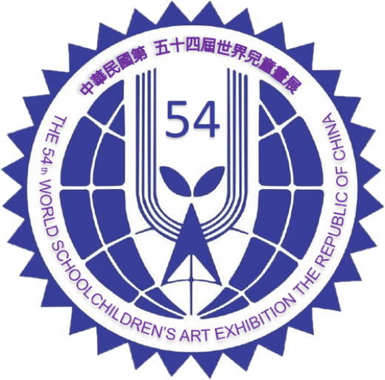
The 54th World School Children’s Art Exhibition
Republic of China (Taiwan)
通訊處  Address | 聯絡人 Contact Person | 學校或機關 School or Institution
路街名稱及門牌號碼，州、省、城市、國名等名稱
Road, Street, and Number ,State, Province, City, Country… etc.

 | 電話 TEL：
 | 電子郵件信箱 E-Mail：
Due to COVID-19, we may have to use carrier like FedEx/UPS/DHL. Please fill in the correct information as well as any other instruction that may help us to clear custom and speed up entire process. (For Example, certain countries will require recipient’s Tax ID )
編號  No. | 姓名  Name | 性別  Sex | 年齡  Age | 畫題  Title | 獎別  Prize

