附件二：講座介紹
- 亞歷山大圖書館館長 Ismail Serageldin
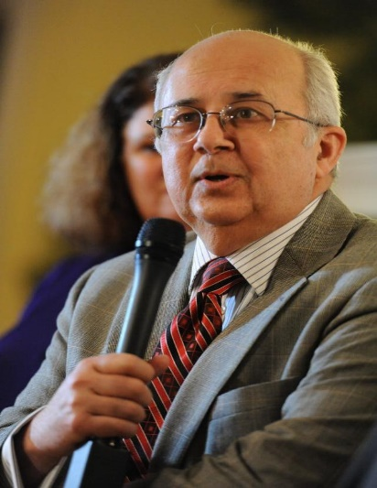 |  | 1.姓名 (Name)  Ismail Serageldin  2.職稱 (Position)  Director (館長)  3.單位 (Affiliation)  Library of Alexandria (亞歷山大圖書館)  4.簡歷 (Biodata)  Education  1964 B.Sc. (First Class Honors) Cairo University  1968 M.R.P. (With Distinction) Harvard University  1972 Ph.D. Harvard University  Honorary degrees  1996 Doctor of Sociology, University of Bucharest, Romania  1996 Doctor of Agricultural Science, University of Melbourne, Australia  1997 Doctor of Science, Indian Agricultural Research Institute, India  1998 Doctor of International Affairs, American University, Washington, DC, USA  1998 Doctor of Science, Punjab Agricultural University, India  1998 Doctor of Science, Tamil Nadu Veterinary & Animal Sciences Univ., India  1998 Doctor of Natural Resources Management, Ohio State Univ., USA  1999 Doctor of Science, Tamil Nadu Agricultural University, Coimbatore, India  1999 Doctor of Science, ANGRAU, Hyderabad, India  1999 Doctor of Economics and Management, CNAM, Paris, France  1999 Doctor of Science, Egerton University, Kenya  1999 Doctor of Agricultural Science, University of Tuscia, Italy  2000 Doctor of Humane Letters, American University in Cairo, Egypt  2002 Doctor of Science, SNHU, Manchester NH, USA  2003 Doctor of Science, McGill University, Montreal, QC, Canada  2004 Doctor of Letters, University of Technology, Sydney, Australia  2004 Doctor of Letters, Université Paul Sabatier, Toulouse, France  2005 Doctor of Laws degree, University of Minnesota, Minneapolis, USA  2006 Doctor of Letters, Université de Nantes, Nantes, France  2007 Doctor of Science, Azerbaijan State Economic University, Baku, Azerbaijan  2007 Doctor of Society Development, Khazar University, Baku, Azerbaijan  2008 Doctor of Letters, Laval University, Quebec, Canada  2009 Doctor of Arts, Beirut Arab University, Beirut, Lebanon  2009 Doctor Diploma, Azerbaijan Cooperation University, Baku, Azerbaijan  2009 Doctor Diploma, National Academy of Sciences, Institute of History, Baku Azerbaijan  2009 Doctor of Letters, University of Dublin, Dublin, Ireland  2010 Doctor Degree, ANAS Institute of Oriental Studies, Baku, Azerbaijan  2010 Doctor Degree, Georgian American University, Tbilisi, Georgia  2010 Doctor Degree, Free University of Tbilisi, Georgia  2012 Doctor Degree, University of Georgia, Tbilisi, Georgia  2012 Doctor Degree, Ilia State University, Tbilisi, Georgia  2012 Doctor Degree, State Agricultural University, Ganja, Azerbaijan  2012 Doctor Degree, Odlar Yurdu University, Baku, Azerbaijan  Currently  Director, Library of Alexandria, and chairman of the board of the ten affiliated research institutes and the four affiliated museums  Ambassador of the Alliance of Civilizations  Chairman of the Executive Council of the World Digital Library (WDL).  Also serves as chair and member of a number of Boards of Directors and advisory committees for academic, research, scientific and international institutions and civil society efforts.  Previous appointments  - Professor, International Chair Savoirs contre pauvreté (Knowledge Against Poverty), Collège de France (2010-2011)  - Distinguished University Professor, Wageningen University, the Netherlands  - Co-Chair of the African Biotechnology Panel (with Calestous Juma)  - Member of the High Level Group (HLG) of the Secretary-General’s UN initiative for the alliance of Civilizations (2005-2006)  - Chairman, Youth Employment Summit (YES) Campaign (1998-2002)  - Special Advisor, The World Bank  - Co-Chair (with Jacob Palis), The Inter-Academy Council Panel on Capacity building in Science and Technology (2002-2004)  - Distinguished Visiting Professor, American University in Cairo (AUC) (2000/2001)  - Advisor to the Egyptian Government on the New Library of Alexandria  - Vice President of the World Bank till July 2000, (for Environmentally and Socially Sustainable Development, from October 1992 to March 1998, and for Special Programs from March 1998 to July 2000)  - Chairman, Consultative Group on International Agricultural Research (CGIAR, 1994-2000)  - Chairman, Consultative Group to Assist the Poorest (CGAP), a microfinance program (1995-2000)  - Chairman of the Global Water Partnership (GWP, 1996-2000)  - Chairman, World Commission for Water in the 21st Century (August 1998-March 2000)  - Vice President of The Academy of Sciences for the Developing World (TWAS)  Worked in a number of capacities at the World Bank since joining in 1972. Economist in education and human resources (1972-76); Division Chief for Technical Assistance and Special Studies (1977-80), and for Urban Projects in Europe, the Middle East and North Africa (1980-83); Director for Programs in West Africa (1984-87), Country Director for Central and Occidental Africa (1987-89), Technical Director for all Sub-Saharan Africa (1990-92), and Vice-President for Environmentally and Socially Sustainable Development (1993-98). In addition, he was active in promoting NGO-Bank relations, and served as Co-Chairman of the NGO-Bank Committee (1997-99). Prior to joining the World Bank, worked as a consultant in city and regional planning, and taught at Cairo University and Harvard University.  Professional Memberships  - Institut d'Egypte (Egyptian Academy of Science), Vice President  - US National Academy of Sciences (Public Welfare Medalist)  - The American Philosophical Society, Philadelphia  - The American Academy of Arts and Sciences  - Academy of Sciences of the Developing World (TWAS) Trieste, Italy  - African Academy of Sciences  - Bangladesh Academy of Science, Dhaka  - National Academy of Agricultural Sciences, India  - European Academy of Sciences and Arts, Austria  - American Institute of Certified Planners (AICP)  - World Academy of Arts and Sciences, USA  - Academia Bibliotheca Alexandrinae (ABA)  - Science and Technology in Society (STS) Forum  - The Royal Society of Arts and Sciences in Gothenburg.  - Supreme Council for Culture, Egypt  - The International Academy of Food Science & Technology, Canada.  - Scientific Advisory Committee of the World Social Science Report 2013, UNESCO  Publications & Speeches  Over 60 books and monographs (edited or authored) and 200 articles, book chapters, and technical papers on various topics, including: Nurturing Development (1995), Sustainability and the Wealth of Nations (1996), Architecture of Empowerment (1997), Rural Well-Being: From Vision to Action (1997, with David Steeds), The Modernity of Shakespeare (1998), Biotechnology and Biosafety (1999, with Wanda Collins), Very Special Places (1999), Promethean Science (2000, with G. Persley), Biotechnology and Sustainable Development: Voices of the South and North (2003, with G. Persley), Discovery to Delivery (2005,with G. Persley), Changing Lives (2006, with E. Masood), Born Digital (2006), Reflections on our Digital Future (2006), Inventing our Future: Essays on Freedom, Democracy and Reform in the Arab World (2nd edition 2007), Science: The Culture of Living Change (2nd edition, 2007) Freedom of Expression (2007) and Islam and Democracy (2008). The Shape of Tomorrow (2010), The Arab cultural Project (2010); Mobiliser le savoir pour eradiquer la faim (the College de France/Fayard, Paris 2011), The Making of Social Justice (the 2011 Mandela Lecture, Johannesburg, South Africa); Alexandria’s Remembrance of things Past: Lessons for the future of Islam and Europe (the 2011 Nexus Lecture, The Netherlands).  Awards:  1999: First recipient of Grameen Foundation (USA) Award for a lifetime commitment to combating poverty  2003: Officer of the Order of Arts and Letters awarded by the government of France  2004: Pablo Neruda Medal of Honor, awarded by the Government of Chile  2006: The Jamnalal Bajaj Award for promoting Ghandian values outside India  2008: Order of the Rising Sun – Gold and Silver Star awarded by the Emperor of Japan  2008: Champion of Youth Award by the World Youth Congress, Quebec  2008: Knight of the French Legion of Honor awarded by the President of France  2010: The Dr. M. S. Swaminathan Award for Environmental Protection (Chennai, India)  2010: Millennium Excellence Award for Lifetime Africa Achievement Prize, by the Excellence Awards Foundation, Ghana  2011: The Public Welfare Medal, by the National Academy of Sciences, Washington DC  2011: Commander of the Order of Arts & Letters awarded by the government of France  Television Programs prepared, produced and presented by Serageldin:  - The Cairo Cultural Salon (a weekly program on Egypt’s Channel 1 - 128 episodes)  - Muslim Scientists (a daily five-minute series aired throughout the month of Ramadan on Egypt’s Channel 1)  - Horizons: (15 science programs of 30 minutes each, presented in two versions in English and Arabic)  - Dialogues on Science: (6 episodes of 45 minutes each, in Arabic)  Personal  Ismail Serageldin is an Egyptian national, born in Guiza in 1944. He is married with one son. He is tri-lingual: Arabic, French and English.  5.演講主題 (Speech topic)  Rebirth and Revolution: The Story of the Bibliotheca Alexandrina  6.演講摘要 (Abstract)  The Ancient Library of Alexandria captured the imagination of the world and remains one of the greatest adventures of the human intellect. Established in 288 BC to bring together the greatest minds of the ancient world, it was a temple to the Muses to which various facilities were attached, including a library. The Library grew and grew and became the greatest library of the age, assembling almost every possible written text known at the time. There bibliography was established, sciences were formalized and debates flourished. It became the intellectual center of the world. A series of fires destroyed the ancient library till by 400 AD it was no more. But its memory as part academy, part library, part university, part research center, and part museum (in the modern sense) continued to haunt the world. 1600 years later it was revived on the same spot. The challenge was how to recapture the spirit of the ancient library in the context of the 21st century. The new, Reborn Bibliotheca Alexandrina has tried to do just that, combining ten research institutes 19 museums and permanent art exhibits, a planetarium, a conference center, and Exploratorium, a high-level informatics center, six specialized libraries and the big library. By the end of 2010 it was annually receiving around 1.4 million visitors and held around 700 events and its websites receive over 3.3 million hits a day.  This unique institution produced interesting results that were saluted by young revolutionaries overthrowing the political regime in Egypt in 2011. It is a wonderful validation of libraries in a time of change.But in the revolutionary turmoil of our country, what will become of this reborn Bibliotheca Alexandrina? Will it survive?

- 丹麥皇家圖書館副館長 Steen Bille Larsen
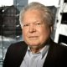 |  | 1.姓名 (Name)  Steen Bille Larsen  2.職稱 (Position)  Deputy Director-general (副館長)  3.單位 (Affiliation)  The Royal Library (丹麥國家圖書館)  4.簡歷 (Biodata)  - Deputy Director General and National Librarian, 2005  - Deputy Director, The Royal Library 1988  - Library Consultant, The Royal Library 1987  - Research Librarian, The Royal Library 1978  - Education: University of Copenhagen, history and literature (MA)  Mr. Steen B. Larsen is Deputy Director and National Librarian with responsibility for the cultural heritage functions in the Royal Library: legal deposit, collection management, preservation, services to the users, cultural activities, digitisation program, digital services - all with respect to traditional formats and digital formats. Deputy Director Larsen has been involved in the digital innovation at The Royal Library from the introduction of IT in the library world. Mr. Larsen’s involvement and the development in th Royal Library are two sides of the same story.  - Deputy Director General and National Librarian, 2005  - Deputy Director, The Royal Library 1988  - Library Consultant, The Royal Library 1987  - Research Librarian, The Royal Library 1978  - University of Copenhagen, history and literature (MA)  - Member of the steering committee for planning and building of The Black Diamond 1992-1999  - Member of the reference committee for reconstruction of the Old Faculty Library for Humanities and Social Sciences. 1992-1995  - Member of The Liber Architecture Group 1995  - Member of requirement board for planning a new Faculty Library for Humanities 2002-2004  - Member of the steering committee for refurbishing of the information area in The Black Diamond 2011-2012  5.演講主題 (Speech topic)  Refurbishing a modern national library building to meet the digital challenges  6.演講摘要 (Abstract)  New modern national libraries have been opened for the public during the last decade: The French National Library, Francois Mitterrand in Paris, France, and the British Library in London, Great Britain. In the same decade The National Library of Denmark opened The Black Diamond in Copenhagen Denmark in 1999. All these libraries were planned in the years when The World Wide Web was invented, based on the invention by Tim Berners Lee.  When we were planning The Black Diamond we were also aware of the invention of World Wide Web. Nobody could tell the consequences of World Wide Web in 1993, but one thing was for sure already in 1993: There would be changes and consequences for the physical library – but how? Therefore we secured with a high degree of flexibility in planning the building. After the opening of The Black Diamond in 1999 many functional changes has taken place in the building. The result is that the building still is heavily used by researchers and students and the building is refurbished to meet the digital challenges in the 21st century.

- 拉脫維亞國家圖書館館長 Andris Vilks
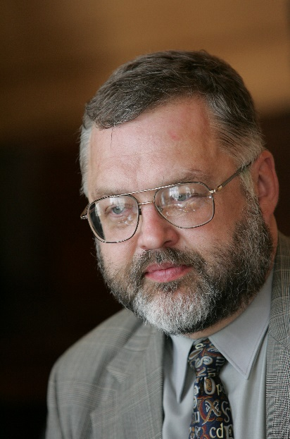 |  | 1.姓名  Andris Vilks  2.職稱  Director-general (館長)  3.單位  The National Library of Latvia (拉脫維亞國家圖書館)  4.簡歷  Andris Vilks is one of the most prominent specialists of the library and information sciences. He has contributed significantly to the development of the library sector and advancement of information and knowledge society in Latvia and the Baltic States. Born in 1957 in Riga, graduated the Doctoral program of the Library and Information Sciences at the University of Latvia. Since 1978 Andris Vilks works in the National Library of Latvia, and since 1989 is its Director.  Since 1989 Andris Vilks is ardently and tirelessly developing the project of the National Library of Latvia The Castle of Light, which includes the construction of the new building of the library, development of the country wide library network and establishment of the National Digital Library.  Andris Vilks holds different positions in national and international organizations. He is a Member of the Board in the Latvian Library Council, the Vice Chair of the Steering Committee for the State Agency “Culture Information Systems” (KIS), a Member of the Steering Committee of Bill & Melinda Gates Project in Latvia, the Chairperson in Latvian National Commission for UNESCO Memory of the World Register and Communication and Information Programme, a Member of the Executive Committee in Latvian National Commission for UNESCO, a Member of International Advisory Committee in UNESCO Memory of the World Register, a Member of the Board in Association of the Libraries of the Baltic Sea Region “Bibliotheca Baltica”.  5.演講主題  The Castle of Light: the New National Library of Latvia  6.演講摘要  National Library is the largest library of the Republic of Latvia – a universal research library, which serves as the legal deposit library, maintains national bibliography and serves as the central hub of library development in the state level. Yet nowadays Latvia is the last remaining European country without a purpose-built national library building. Currently The National Library of Latvia is located in six separate buildings, none of which are suited to the specific needs of a national library and all of them being in a very poor technical state.  The construction works of the new building of the National Library of Latvia (The Castle of Light) were started in 2008 and by the end of 2013 the construction of the new building is expected to be completed.  The architect of the National library project – internationally acclaimed Latvian born American architect Gunnar Birkerts has a deep understanding of the essence of a library, its tasks and structure. He has created an expressive form for a well functioning body.  The key characteristics of the new building of the National Library of Latvia (Castle of Light or Glass Mountain) are FLEXIBILITY, LIGHT and PLACE. National libraries initially were closed repositories, intended only for eternal preservation of physical materials. Now national libraries are becoming flexible and freely accessible to everyone. Castle of Light is a literary metaphor, familiar to the whole Latvian nation. Furthermore it involves the most direct connection of the metaphoric meaning to the technical demands of the library. Books should be isolated from sunlight, but readers and staff should have daylight whenever possible. Light is one of the favourite “raw materials” of the Gunnar Birkerts, and atrium is a tool for the daylight spreading to everyone in the library. A library is a place where people meet. The open, communicative philosophy of libraries of the recent decades has been emphasized in their new constructions. In new circumstances these libraries take on new dimensions.  The new building of the library will provide a comfortable space for study and research, as well as qualitative remote services and digital collections. As the aim of the National Digital Library is ensuring availability of digitised Latvian cultural and historic heritage, it gives access to full text resources on history, geography, economy and politics – a well designed platform for thematic research. The Castle of Light will be place for several events: large and small scale exhibitions, movie evenings, book openings, authors’ lecturers, different conferences and workshops, happenings and much more.

- 蒙古國家圖書館館長 Khaidav Chilaajav
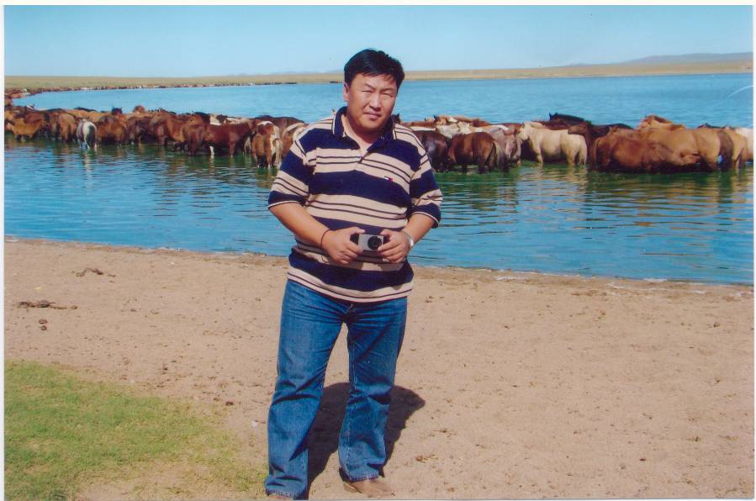 |  | 1.姓名  Khaidav CHILAAJAV  2.職稱  Director-general (館長)  3.單位  National Library of Mongolia (蒙古國家圖書館)  4.簡歷  MR. CHILAAJAV KHAIDAV (MSc.) (MBA.)  PRESIDENT & CEO, WRITER’S UNION OF MONGOLIA  CHAIRMAN OF THE NATIONAL COUNCIL OF THE MNB  DIRECTOR OF THE NATIONAL LIBRARY OF MONGOLIA  General information  - Full name CHILAAJAV Khaidav  - Date of birth November 07, 1967  - Place of Birth Gobi-Altai Province, Mongolia  - Marital status Married  - Profession/ Qualification Poetry/Literature  - Foreign language ability Russian, English  Education  - MA. Literature, Educational University, Mongolia, 2005  - MSc., University of Agriculture, Mongolia, 1999  - MBA., Academy of Management, Mongolia, 2000  - BA. Journalism, National University of Mongolia, 1998  Work Experience  - Started as parliamentary correspondent at Mongolian National Radio in 1994  - Editor-Interpreter at Mongolian National Radio, 1995  - Editor-In-Chief, Youth Programming Department, Mongolian National Radio, 2000  - Director, Mongolian Literature Publishing House, 2001  - President & CEO, Writer’s Union of Mongolia, 2001  - Board Member, “Mongolian Literature” newspaper, 2005  - National Council Member, Mongolian National Broadcaster (MNB) – The National Public Radio and Television, 2005  - Chairman of the Board, National Council, MNB, 2006  - Member, Minister’s Council, Ministry of Education, Science and Culture, Mongolia, 2005  - Director of Mongolian National Library , since 2010 to present  Titles & Awards  - Cup Winner ‘Nairgiin Daaga’ - Poetry Festivals ‘1992  - Special Prize Winner, ‘Crystal Cup’ -The Supreme Poetry Contest of Mongolia ‘1992  - The Best Creative Work Winner, “Goo Maral” – The Grand Awards of Art & Culture Sector, Mongolia ’1997  - Honor of Writer’s Union, Mongolia, 2005  Publications  - THE ALTAI MOON, 1994  - I DO HAVE MY OWN NATIVE COUNTRY, 2001  - BOOK FOR CHILDREN SERIES 1, 2, 3, 4, 5, 2002  - MY VAST HOMELAND THE ALTAI, 2004  - BIRDS THAT ARE FLYING BEYOND SKY HORIZON, 2005  - THE NEW ROADS OF THE OLD WORLD, 2007  Songs  of which  lyrics are  written by  - ‘NATIVE COUNTRY’  - ‘I LOVE MY FATHER’  - “KHANTAISHIR”  - ‘MONGOLIA-THE MELODIOUS COUNTRY’  - ‘GREAT MONGOL EMPIRE’ etc., songs are well known amongst Mongolians.  5.演講主題  Future development trends of the National Library of Mongolia  6.演講摘要  National Library of Mongolia was founded in 1921 at the Academy of Sciences of Mongolia. Book exchanges between the Library and foreign libraries were initiated as early as 1924 and the Library became a member of the International Federation of Library Associations and Institutions (IFLA) in 1991. To date, the Library has book exchange programs with over 100 libraries in 70 countries. The purpose of the National Library of Mongolia, according to its Rules of Organization and Operation, is “to collect and preserve manuscripts, sutras, academic degree dissertations, as well as books and periodicals that are published in Mongolia and significant foreign books and periodicals; to create a national bibliography; to serve efficiently the library users with the above material and to provide other public libraries with professional methodology, guidance and information.”  National Library of Mongolia has an enormous role in the society for the achievement of the Government’s objective “to make ICT a stimulus for development and to lay the foundations of knowledge-based society”. However, the National Library of Mongolia today is facing major challenges in collecting information and knowledge resources and in delivering them to the users in reliable, accessible, convenient and economical ways. National Library sets out the four main priorities in the future.  Content and Access  In collecting and enriching its content in, the National Library of Mongolia will give priority to:  - users’ needs and demands;  - improving the quality of the print based content and collecting electronic content and providing access to it;  - ensuring long-term and reliable storage, preservation and dissemination.  Given the above priorities, major jobs will be done to renew and enrich the content. Specifically, the Library will collect and provide access to:  - rare and valuable books and ancient manuscripts  - contemporary print based and digital material, including the digital resources in Mongolian  - foreign books and journals relating to Mongolian studies  - works and publications by Nobel laureates  - works and publications of the latest scientific advancements and breakthroughs  - electronic database relating to sciences and research.  Users and Partnership  Needs and demands of the users will be carefully studied, which will enable the Library to improve the quality of the present collections, services and deliver new services. As a result, the Library will acquire new users, such as:  - scientific researchers in various disciplines  - disabled individuals  - vulnerable social groups (including individuals in remote locations, artisan miners, migrant workers)  - individuals in specific institutions (such as prisons or hospitals)  In addition, value-added and fee-based services will be specially developed for and offered to businesses, small and medium enterprises, mining companies and tourists.  Digital Library  The Digital Library project will comprise two components: software and content. The content will be in the electronic format. Electronic copies of printed materials, when possible, will be also delivered through the Digital Library. The Digital Library will be able to provide readers with a wide range of high quality electronic databases. Implementation of this digital library strategy will require:  - securing legal regulations (digital content management)  - technology and equipment upgrading (information technology infrastructure)  - creation of information safety environment  - human capacity building  Human Resource  The present human resources of the Library comprise professionals trained in the former USSR during the socialist period and have not been adequately re-trained or updated regarding the skills needed for using modern technologies; applying such technologies to library services and collecting, processing and disseminating digital contents. Language skills and competence in the staff is limited to Mongolian, Tibetan, Russian, Korean and Chinese.  To secure the human capacity required for the new organization and structure, the Library is planning to:  - systematically cover the present staff in re/trainings to build the needed capacity;  - prepare a proposal for improvements in the curriculum of training of the future staff and submit it to the Ministry of Education, Culture and Sciences; collaborate with professional training institutions and schools in such efforts;  - implement a policy to employ professionals from information technology, foreign languages and other relevant and desired fields;  - employ talented, experienced human resources specialists and business managers on short-term contracts for specific projects; acquire skills from such professionals through collaboration;  - employ foreign experts and consultants;  - provide the staff with economic benefits and a rewarding environment to encourage long-term, sustained employment and commitment.

- 越南國家圖書館副館長 Kieu Thuy Nga
 |  | 1.姓名  Kieu Thuy Nga  2.職稱  Deputy Director-general (副館長)  3.單位  National Library of Viet Nam (越南國家圖書館)  4.簡歷  Affiliation:  - Deputy Director, National Library of Viet Nam  - Member, IFLA Asia and Oceania Section Standing Committee  Education:  - Year of 1991: Bachelor degree of Library and Information Science, Hanoi Cultural University, Viet Nam  - Year of 1997: Bachelor degree of Foreign language in English, Foreign languages College, Viet Nam National University  - Year of 2005: Master degree of Library and Information Science, Hanoi Cultural University, Viet Nam  Professional publications and achievements:  - Article “Cataloguing in Publication at the National Library of Viet Nam”. Viet Nam Library Journal, 2010  - Seminar Paper “RDA and current application of RDA”. Seminar “Resources Description and Access and possibilities of application in Viet Nam”,Hanoi, 2011.  - Chief Editor of “Set of keywords” published by the National Library of Viet Nam, 2012.  - 2009 - present: Coordinator of the project “Cataloguing in Publication in Viet Nam”  5.演講主題  Develop the National Library of Viet Nam towards a traditional-modern-digital library  6.演講摘要  This article discusses about the activities of the National Library of Viet Nam (NLV) to develop the library in the direction of traditional combined modern digital library, building digital library by developing the appropriate collections; preserving and promoting cultural heritage of national writings to disseminate knowledge of the nation to numerous domestic and foreign readers; applying information technology to control, share resourses and enable users approach easily to library resources as well as access to other information resources from outside the library.

- 法國國家圖書館副館長 Arnaud Beaufort
 |  | 1.姓名  Arnaud Beaufort  2.職稱  Deputy Director-general (副館長)  3.單位  The National Library of France (法國國家圖書館)  4.簡歷  5.演講主題  Digital services to users and professionals of the National Library of France (BnF)  6.演講摘要  Through its digital library Gallica, the BnF offers a large and diversified array of services to its users: access to up to 2 million scanned and OCRed texts, images and objects; HD-images download; document sharing via an exportable viewer; print-on-demand service; apps for smartphones and tablets; semantic search engine; online mediation ( newsletter, Facebook,Twitter, Pinterest, blog).  Furthemore, the BnF also offers services to professionals such as an extranet for legal deposit forms (publishers), a white label digital library (libraries), third-party digital archiving (public organisations), and a set of bibliographic data released under governmental open license.

- 德國巴伐利亞邦立圖書館副館長 Klaus Ceynowa
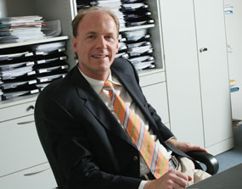 |  | 1.姓名  Klaus Ceynowa  2.職稱  Deputy Director-general (副館長)  3.單位  The Bavarian State Library (巴伐利亞邦立圖書館)  4.簡歷  Dr. Klaus Ceynowa is the Deputy Director General of the Bavarian State Library at Munich, Germany. His main fields of work are strategic and financial planning, human resources management, and controlling and marketing for libraries in the digital age. He was responsible for negotiating the contract between the Bavarian State Library and Google about the digitization of the complete copyright-free collections of the Library from the 17th to the 19th century, which is more than 1 Million books. He is deeply engaged in all innovative projects of the Bavarian State Library, e.g. 3D-Internet applications, ScanRobotics, technologies for longterm digital preservation, Linked Open Data, gesture-based computing, and Mobile Applications as well as Augmented Reality tools and Location-Based-Services for libraries.  5.演講主題  Connecting Users and Content Beyond Keywords: The National Library of Singapore’s experience  6.演講摘要  The future of the digital world of knowledge will be determined by three major trends in web technology: the transition from the stationary to the mobile internet, the predominance of highly personalized applications available on the spot (e.g. location-based services), and the replacement of keyboard and mouse by natural user interfaces (from GUI to NUI, gesture-based computing). Basically this means the end of the familiar„internet working place“ as the primary way for distributing and accessing digital information in favour of the „all-pervasive internet“ that will be fully integrated in our daily routines of work and life. How can digital content and information be optimally designed and processed in order to function seamlessly in the new user scenarios of mobile and personalized knowledge worlds? The Bavarian State Library has been experimenting for some years in the field of tools, methods, and services for the „contextualization“ of digital content: mobile apps, augmented reality, location-based services, 3Dcomputing,gesture-andpicture-based search and presentation systems are some examples that will be shown and discussed with respect to their potential for innovative information services. It thus becomes clear that a rich, multi medial offer of digital content and services is only half way to success. What equally counts is the seamless integration of content and services into the fascinating and immersive user scenarios of future digital life.

- 國立俄羅斯圖書館館長 Anton V. Likhomanov
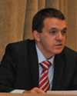 |  | 1.姓名  Anton V. Likhomanov  2.職稱  Director-general (館長)  3.單位  The National Library of Russia (國立俄羅斯圖書館)  4.簡歷  Anton V. Likhomanov was born in 1964, in Leningrad. He has been working in the National Library of Russia since 1981. He occupied various posts: as the librarian, as the head of funds and service department, as the Deputy Director. In January 2011 he was appointed as Director General of the NLR’s.  Anton.V. Likhomanov is one of the most respected people in the librarianship in Russia; he takes part in the development and implementation of several government programs, the author of more than 40 scientific works on a library science, history of censorship and printed media in Russia and libraries security.  Anton.V. Likhomanov graduated from the St.-Petersburg University, he has a PhD in History.  5.演講主題  The National Library of Russia in the XXI century: Searching for new ways of the development  6.演講摘要  The National Library of Russia (NLR) – is the first Public library of the Russian Empire. It was founded in 1795 and in 1814 was opened for readers.  The NLR preserves over 36,500,000 books and other materials, annually it serves one million visitors and loans about 7 million items. At the present day, the total area of the premises occupied by the NLR is 115 thousand meters.  By the volume of its collection the NLR is one of the five largest libraries in the world. The National Library of Russia has the most complete collection of literature in Russian, published prior to 1917, as well as a rich collection of manuscripts and rare books.  The NLR has been receiving an obligatory copy of all printed materials published in Russia since 1810. In 2011, the Library received 448.3 thousand publications.  Currently, a place and a role of the NLR in the library system of the country and of the world is influenced by qualitative changes in the library and information environment, the most significant of which are:  - wide extension of electronic publications and revaluation of the role of information for areas of interest and the development of society and individuals;  - the development of new information technologies: digital preservation and remote distribution of bibliographic, textual, visual or other information, possibility for providing an access to information without intermediaries;  - increase of the value of information, which limits the possibilities of each of the libraries, and as a consequence - the formation of library and information networks, the development of corporate partnership;  - increase of demands for services provided by libraries and needs of staff are in constant updating of knowledge and competence.  The main directions for the development of the NLR in the XXI century are:  - automation of library processes: the creation of electronic catalogs, digitization of books on hard copy;  - use of new ways for preservation of the most valuable collection in the Library;  - transformation of the library into an important cultural center;  - the development of research;  - strengthening the material and technical basis, the completion of the new building;  - staff development.  More information about the work in each area would be given in the report.

- 新加坡國家圖書館館長 Ngian Lek Choh
 |  | 1.姓名  Ngian Lek Choh  2.職稱  Director-general (館長)  3.單位  National Library Board Singapore (新加坡國家圖書館)  4.簡歷  5.演講主題  Connecting Users and Content Beyond Keywords : The National Library of Singapore’s experience  6.演講摘要  In today's highly interconnected internet and mobile world, the average user has access to a wide range of search engines and mobile devices to search and find information.  How do libraries add value to users when most of them are able to find the information that they need without the help of libraries and librarians. Many users have told us that they do not need the authoritative information that libraries and librarians say that libraries have, and that users may not have easy access outside the library's system. They just do not care enough for this, as they do not need that completeness nor total accuracy for most of their information needs.  The National Library Board (NLB) of Singapore has been developing and innovating its library services the past 17 years in an intensive manner. Today, we can say we are probably up there where the physical library service is concerned. Everything that can be automated and everything that we can let users do themselves are done by users. Though Singapore has a small population of 5.3 mil in an area of some 670 sq km, the NLB's 25 libraries receive over 38 mil visitors annually. And most of them are very satisfied users, at least in the realm of the physical library services.  Over the past 6-7 years, the NLB digitised a sizeable proportion of its heritage content, including complete runs of newspapers for eg, The Straits Times, from 1845 to date. The newspapers which are OCRed can be searched and retrieved from anywhere from 1845-1989 using keywords. Content after 1989 can be accessed onsite. This proves to be a very popular and highly valued service. Over 6 mil page views are recorded last year. A large proportion of these users found the NewspaperSG service through Google and other search engines.  Our focus now is to look at how we value add to users on the digital side. We feel that on top of just allowing users to key in keywords to search, there must be more effective ways to enable users to find what they want in an easy and precise manner, once they find us through any search engine. We present some of these ideas in our presentation, including linked data, data mining and text analysis. We will illustrate with some examples of how we foresee the way forward. Most of this work is still experimental and not conclusive yet.

- 加拿大國家圖書檔案館副館長 Daniel J. Caron
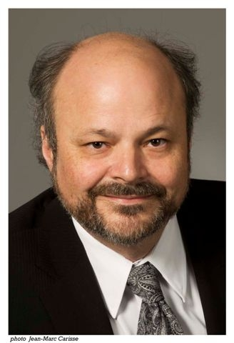 |  | 1.姓名  Daniel J. Caron  2.職稱  Deputy Head and Librarian and Archivist of Canada and Chair, Heads of Federal Agencies  (副館長)  3.單位  Library and Archives Canada (加拿大國家圖書檔案館)  4.簡歷  Daniel J. Caron joined the federal public service in 1982. In 2009, he was appointed Librarian and Archivist of Canada. One year later, he launched the modernization initiative to ensure that Library and Archives Canada could meet the multiple challenges of the digital environment. This initiative is a call for collaboration, epistemologically grounded institutional policies and policy driven decisions. In addition to his organizational experience, Mr. Caron is a seasoned author and speaker on public administration and issues related to information and memory both in Canada and abroad. Mr. Caron has also taught in several Canadian universities. He holds a bachelor’s degree and a master’s degree in Economics from the Université Laval, and obtained a doctorate in Applied Human Sciences from the Université de Montréal. Mr. Caron has been Chair of the Forum of National Archivists for the International Council on Archives since 2010.  5.演講主題  Future Discretion of the National Libraries  6.演講摘要  Approaching its 150th anniversary, Canada is a nation in constant evolution. Likewise, Canada’s National Library and Archives have also evolved. From a National Archive reflecting Canada’s status as a Dominion, with the addition of a National Library some years later, to a modern organization incorporating its two venerable institutions. In 2014, Library and Archives Canada (LAC) marks its 10th anniversary, and stands ready to meet the challenges of the twenty-first century as a modern memory institution. While remaining a world leader in analogue preservation, LAC is now adapting its business practices to meet the demands of the digital information revolution in the manner it acquires, preserves, and makes known Canada’s documentary heritage. Working in a collaborative network with its documentary heritage partners, LAC endeavors to keep pace with the profound societal changes now in play.

- 國立臺灣師範大學圖書資訊學研究所教授兼圖書館館長
陳昭珍教授
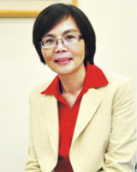 |  | 1.姓名  陳昭珍  2.職稱  教授  3.單位  國立臺灣大學圖書資訊學研究所  4.簡歷  國立臺灣師範大學圖書館館長  國立臺灣師範大學圖書資訊學研究所所長  國立臺灣師範大學社會教育學系副教授、教授  國立臺灣大學圖書資訊學系副教授  輔仁大學圖書資訊學系講師、副教授  國家圖書館輔導組兼閱覽組主任  國立臺灣大學圖書館編目組主任  5.演講主題  MOOCS and Library Services: the  Opportunities and Challenges  6.演講摘要  The recent growth in offerings of Massive Open Online Courses (MOOCS) has led to many discussions of technology replacing traditional higher-education teaching. Here we analyze the origins and history of MOOCS, as well as trends in education established by these online courses. First, we compare and contrast MOOCS with earlier platforms of online learning, such as Distance Learning, E-learning, and Open Course Ware (OCW). We look at the content and usage similarities, as well as each platform’s impact on the evolution of higher education. Secondly, we examine the online educational resources of Taiwan, especially the development of OCWmaterials. Thirdly, we use the OCW offerings of National Taiwan Normal University and National Chiao Tung University (Transportation University) as a basis for discussion of opportunities for higher education. We present findings of user surveys about OCW courses, the course’s impact on learning, and the role of libraries in managing OCW resources.

- 國立臺灣師範大學圖書資訊學研究所吳美美教授
 |  | 1.姓名  吳美美  2.職稱  教授  3.單位  國立臺灣大學圖書資訊學研究所  4.簡歷  3.2002-date  Professor , National Taiwan Normal University  3,2002-7, 2005  Chairperson, Graduate Institute of Library & Information Studies, National Taiwan Normal University  7,2001-3, 2002  Professor, Department and Graduate Institute of Adult and Continuing Education, National Taiwan Normal University  8,1995-6,2001  Associate Professor, Department and Graduate Institute of Adult and Continuing Education, National Taiwan Normal University  2,1993-7,1995  Associate Professor, Graduate Institute of Educational Media and Library Science , Tamkang University  2,1989-7,1991  Lecturer, Department of Educational Media  and Library Science, Tamkang University  10,1988-6,1989  Librarian Coordinator, Bibliographic Network Project, National Central Library  8,1988-1,1989  Part-time Lecturer, Department of Educational Media and Library Science, Tamkang University  8,1986-7,1988  Teaching Assistant, School of Communication, Information and Library Studies, Rutgers University  5.演講主題  e-Research and Library Development – Some Observations  6.演講摘要  e-Research and Library Development – Some Observations  According to Andersonand Kanuka (2003)[1] “the e prefix means that the activity or noun modified takes place on a high-speed, digital network that is available "any-time/anywhere." Today that network is the Internet.”e-Research is thus the research activities that apply a spectrum of advanced information and communication technology (ICT) capabilities and embraces new research methodologies emerging from increasing access toNetworks,Services, andTools” [2]This presentation will report some observationsregarding the environment, infrastructure, projects, e-Researchers, as well as libraries’ efforts.From which, suggestions for local library development to support e-Research are proposed.

- 國立政治大學圖書資訊與檔案學研究所教授兼所長
薛理桂教授
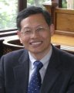 |  | 1.姓名  薛理桂  2.職稱  教授  3.單位  國立政治大學圖書資訊與檔案學研究所  4.簡歷  5.演講主題  Long-term Preservation Policy of the National Central Library  6.演講摘要  The development of information technology is rapidly in last two decades. The media of information storage are also toward to multiple. How to establish a long-term preservation policy is the major issue for a national library. Two case of nation libraries are discussed, i.e. the National Library of Australia and the National Library of New Zealand. Furthermore, the current status of the preservation policy of the National Central Library is described. Finally some suggestions for the long-term preservation policy are given for the National Central Library.
  教授 | 圖書資訊與檔案學研究所 | 2010年08月 ~ 2013年01月
  教授 | 圖書資訊與檔案學研究所 | 2005年08月 ~ 2010年02月
  教授 | 圖書資訊與檔案學研究所 | 2004年08月 ~ 2005年02月
  教授 | 圖書資訊與檔案學研究所 | 1996年08月 ~ 2004年02月

