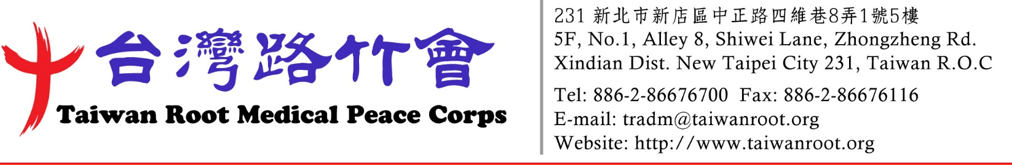

Subject: Time for Taiwan to feedback its Love to the world
Dear Administrator,
I hope this letter finds you well. I am writing on behalf of Taiwan Root Medical Peace Corps (TRMPC, or “Taiwan Root”) , a global medical rescue organization established in Taiwan in 1995, dedicated to providing free medical services for the past 29 years. TRMPC was ranked No.168 in Top 200 Leading Social Good Organization in 2024 ( https://thedotgood.net/ranking/2023-world-200-sgos).
Find the track of TRMPC in major world disasters:
1999 Kosovo War “Stenkovec refugee camp” mission, TRMPC was the only medical team from Asia. Israel Army medical team visited TRMPC’s camp. (see attach 1)
2004 South Asian Tsunami medical mission. The team with 42 members brought about 2000kg of medicines and equipment. After the mission, TRMPC donated 67 containers of rice and were received by the Prime Minister Mahinda Rajapakse who became the President the next year (see attach 1)
2010 Haiti Earthquake medical mission. TRMPC was the largest non-governmental medical team in the world according to UNHCR. Total 66 members including 23 physicians with 10 specialties. The team brought about 2500kg of medicines and medical equipment. TRMPC worked 24 hours with two shifts in local hospitals and camp, even USA Marines sent the patients to our camp. (see attach 2)
2013 Philippines Typhoon Haiyan medical mission (Meet Israel Army medical team again after 1999 mission, see attach 3)
TRMPC also provided 3 to 6 months free advance medical training for African physicians in the cooperative teaching hospitals in Taiwan. From 2009 to 2018, there were total 18 medical professionals from Kenya, Nigeria, Sudan, and Uganda came for the trainings. (See MOU and photos attach 4)
When TRMPC started to provide medical services for Tibetan in Dharamshala, India, His Holiness 14th Dalai Lama showed his appreciation and invited the team to his official residence. (See attach 5). So as 17th Karmapa invited TRMPC for group picture to thank our efforts in the mission in Bodh Gaya, India. (See attach 6)
TRMPC organizes the medical team with physicians, dentists, pharmacists, medical technologists, nurses, and general volunteers as a mobile hospital for each mission. From the beginning till now for 29 years, there are total 425 missions completed. (See intro attach 7)
We are confident that by leveraging our expertise and resources, we can have a substantial impact on global healthcare, ultimately saving lives together. The participation of your institution, including medical doctors, pharmacists, and nurses, and medical students would significantly enhance our collective effort to deliver high-quality healthcare to underserved populations worldwide.
Please inform us if you are interested in joining us for at least one of our 18 annual medical missions. (See mission schedule attach 8) We will document all your contributions and provide you with unforgettable photo memories. You can find more information about our past missions by following this hyperlink: http://www.taiwanroot.org/about.php?l=en&id=194
Thank you for considering our invitation. We eagerly await your response.

Warm regards,



Dr. Chi-Chun Liu
President,
Taiwan Root Medical Peace Corps (TRMPC)
(http://www.taiwanroot.org/index.php?l=en)

