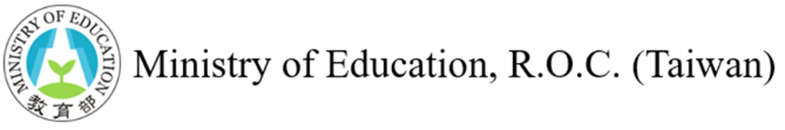
Employing Taiwan's Mandarin Teachers / Assistants in the U.S.
In December 2020, Taiwan and the U.S. launched the U.S.-Taiwan Education Initiative, a project designed to strengthen international education collaboration, with a specific focus on language education. In 2023, the two sides announced a three-year strategic plan (2023-2025) to broaden this collaborative effort, extending it to K-12 education and academic alliances between universities in Taiwan and the U.S.
The Ministry of Education (MOE) of Taiwan, committed to fostering global Mandarin proficiency, has instituted a comprehensive financial aid program for our highly trained Mandarin teachers and teaching assistants to teach overseas. In 2022 alone, this initiative enabled 32 Mandarin teachers and 48 teaching assistants to bring their expertise to American classrooms.
Program Promises
- The MOE subsidies covering round-trip airfare and a monthly stipend for one year (Teachers: US$1,600/month, Assistants: US$800/month), topped with a one-time teaching materials allowance for Mandarin teachers.
- Assistance in recruiting trained and qualified teaching personnel.
Responsibilities of the Cooperating Institution
- Be officially recognized by the U.S. government or a professional accreditation agency for education.
- Provide a salary, which could include additional benefits such as insurance, accommodation, and professional development opportunities.
Application procedure
Interested educational institutions should submit an official request letter and the Information Form for the program (attached) to the Education Division of the nearest local Taiwan missions.
Procedure
- An interested education institute contacts the Education Division of the nearest Taipei Economic and Cultural Office.
- The interested education institute provides a job description and salary information.
- The Education Division relays the information to the MOE.
- The MOE disseminates the job information.
- The interested education institute independently conducts interviews and selects their preferred candidates.

Employing Mandarin Teacher from Taiwan - Information Form
Country
Cooperating university /organization/school
Person-in-charge
Number of teachers to be employed
Applicant qualifications/eligibility
(including teaching qualification & any other credentials), and application deadline
Period of employment
Monthly salary provided by cooperating university/organization/school (before / after taxes)
Support provided by cooperating university/organization/school
(i.e. health insurance, accommodation, training opportunities, tax-exemption, holidays & leave, employment visa)
Support provided by Taiwan MOE  (i.e. monthly living stipend, round-trip airfare subsidy, teaching material allowance) | - Monthly living stipend: (Teachers: US$1,600/month, Assistants: US$800/month)  - Round-trip airfare subsidy: maximum US$1,750  - Teaching material allowance for teachers: US$300
Course content and teacher duties
(including weekly teaching load and any other duties)
Course level(s)
Any other material applicant should provide (e.g. short video of their teaching)
Contact person / contact method
Remarks

